Extra Practise-Number Relationships
Directions: Work through these questions as extra practise for the unit.
Please show your work on each question.

Topic 1-Squares:

- What are two ways to represent a square number? Give an example for each.

- What is a perfect square?

- Using prime factorization, determine if 36 is a perfect square. Show your work.

- What is the area of a square garden if the side length is measured at 4m?

4m

- For the school assembly, the students are made to stand so that the number of rows is equal to the number of students in each row. If there are 67 rows, how many students were present at the assembly?

Topic 2-Square Roots:

- How is a square number and a square root related?

- What is the side length of the square shown?

81 cm²

- A helicopter landing pad has a square shape. The area of the pad is 400 m². Determine the side length of the helicopter pad.

- Evaluate.
  - √25

  - √1600

  - √100

  - √4

- Adam’s uncle has instructions for building a shed. One page of the instruction is not very clear. Use the diagram below to determine the area of the rectangle and the side length of the square.
4 m
Area of rectangle = area of square
9m

Topic 3-Estimating Square Roots

- Using a number line estimate the square root of each number to the nearest tenth.
  - 72

  - 103

  - 55

- Identify a whole number with a square root between 11 and 12.

- While shopping online, Ji Hun finds a square rug with an area of 11 m². He needs to know if it will fit in his 4 m x 5 m bedroom. Estimate, then calculate. Will it fit?

11 m²

- Order the following numbers from least to greatest: 7, √46, 5.8, √27, 6.3.

- A classmate has created a riddle related to this topic. The number has a square root between 7 and 8, and it is a multiple of 12. What number could they be thinking of? Is there more than one answer?

Topic 4- Pythagoras Theorem
- What is the formula, or relationship, between the all sides of a right angle triangle?
Hint: look at the diagram below.
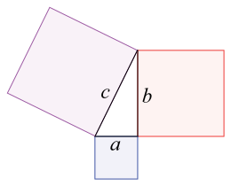

- How do you know when a triangle is not at a right angle?

- Determine the length of the hypotenuse for the given triangle.
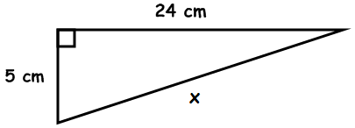

- Determine the length of the missing side.
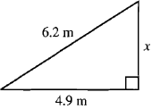

- Tina wants to construct a path along the diagonal of her yard. What length will the path be? Express your answer to the nearest tenth of a meter?
6 m
12 m
Diagonal

