Math 8 Unit 1 – Hand in #1

- Which of the following are perfect squares?
64 100 73 75 81 1 16

- A square floor mat in a gym has a measurement of 125m². What are the height and width of the mat to the nearest tenth?

- Calculate.
- 3.5² b) 15²

- 17² d) 20.2²

- What is the prime factorization of 36?

- A square grid has a length and width of 20cm. What is the area of the grid?

- Calculate and round to the nearest tenth.
- $\sqrt{35}$ b) $\sqrt{71}$

- $\sqrt{25}$ d) $\sqrt{243}$

- Mrs. Dewacht told her students’ to run around the perimeter of the school field. The area of the square field is 28 700 m². What distance did the students run?

- In Japanese tea rooms the floors are usually covered with square and rectangular tatami mats. The area of a half mat is 8100 cm² and is half the size of a full mat.

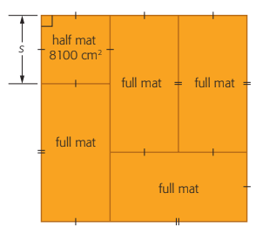
- What is the measure of the length(s) of the half mat?

- What are the dimensions of the full mat?

- What is the total area covered by the tatami mats?

