Unit D Assignment Booklet
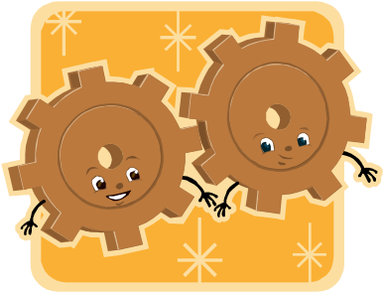
Mechanical Systems

Name: ___________ ________________
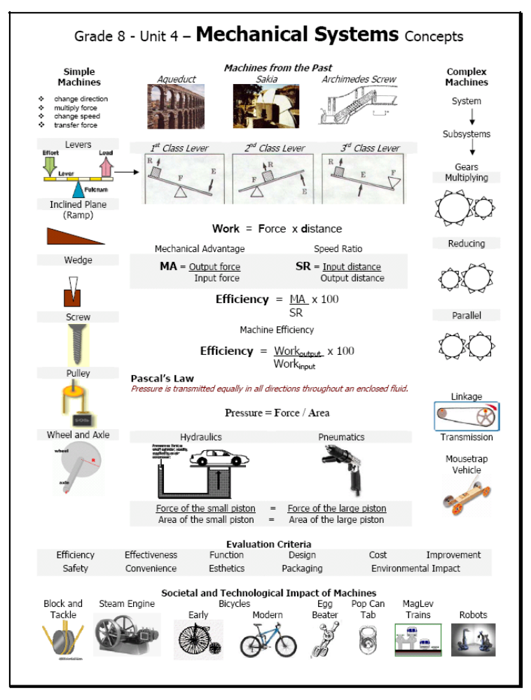
Levers
- I can identify components that operate as simple machines
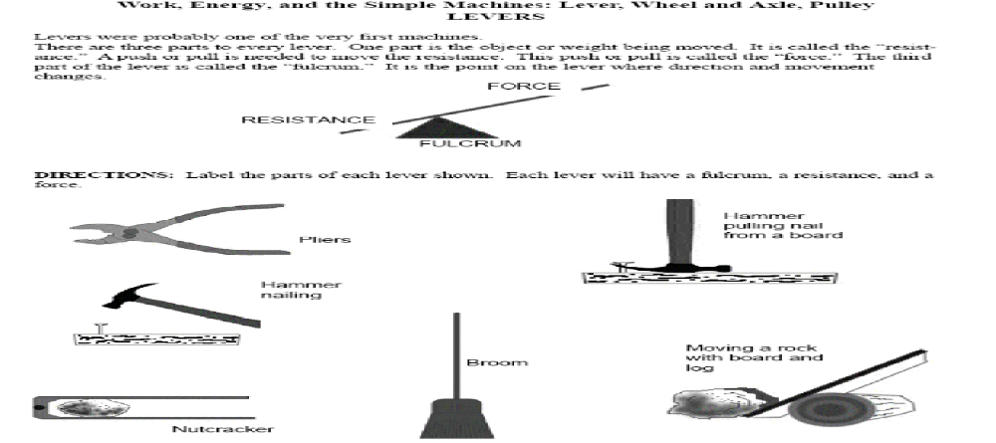
- Label the parts of each lever shown. Each lever will have a fulcrum, a resistance, and a force..
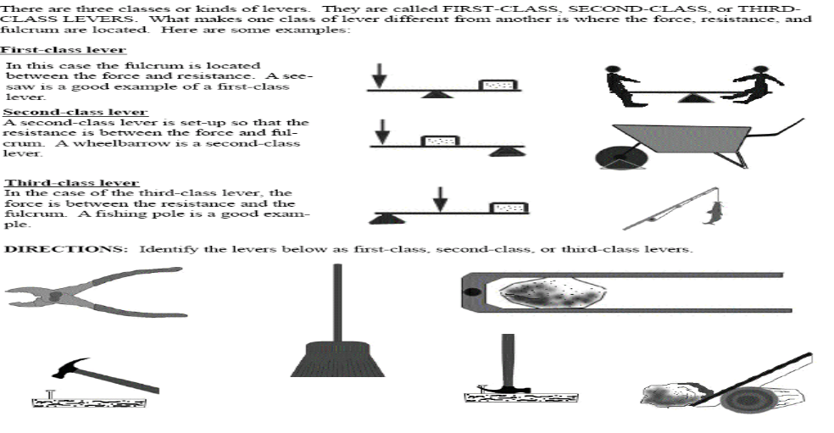
- Identify the levers in the above question as first, second or third class levers.
Mechanical Advantage Calculations
- I can analyze mechanical devices to determine force ratios
Use the formula below to answer the following questions. Show all of your work and classify each lever as having a speed advantage (MA less than 1), a force advantage (MA greater than 1) or no advantage. (MA = 1)
Mechanical Advantage = Load Force MA = F_{L}
Effort Force F_{E}
- Calculate the mechanical advantage of a lever that is able to lift a 300 N rock with an effort force of 50 N.

300 N

50 N
Type of advantage: ______________________
- A baseball bat can exert a force of 40 N when the force applied by a person’s hand is 500 N. What is the mechanical advantage of the bat?
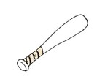
40 N
500 N

Type of advantage: ______________________
- A crafty coyote is trying to use a catapult to launch a heavy rock. The rock, with a weight of 10000 N, sits on one end. He uses a small rock as the fulcrum between the rock and himself. The coyote figures that if he jumps on the other end of his plank, his 250 N weight will be enough to launch the rock into the air. Calculate the mechanical advantage the catapult must have for the coyote’s plan to work.

Type of advantage: ______________________
- A ramp is used to lift a box that weighs 60 N. How much effort is required if the mechanical advantage is 3?

Type of advantage: ______________________

- Use the information given to calculate the mechanical advantage of the pulley system.

A pulley as shown is used to lift a weight.

Input Force = 5.2 N

Output Force = 10.0 N

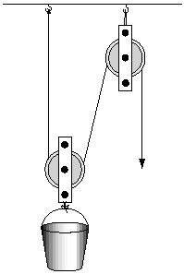

Type of advantage: ______________________
- Use the information given to calculate the mechanical advantage of the wheel and axle.

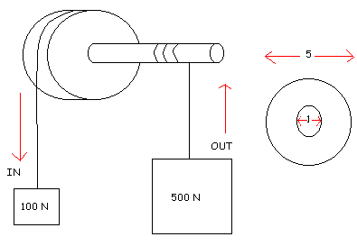
Type of advantage: ______________________

- By applying a force of 20 N to a pulley system, a person can lift a 100 kg box of fruit. What is the mechanical advantage of the system? [Hint: the weight of a 1 kg box is 10N]
20 N

100
kg

Type of advantage: ______________________

- If a lever has a MA = 4, how much weight could a person lift by applying 100 N of force?

Type of advantage: ______________________
Mechanical Advantage of Levers
- I can compare theoretical and actual values of force ratios, and propose explanations for discrepancies
- The theoretical MA can for a lever can be calculated by dividing the length of the effort arm by the length of the resistance or load arm:
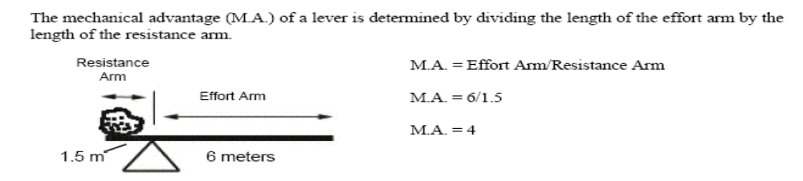
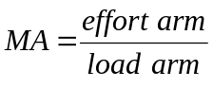
- Remember: The actual MA can for a lever can be calculated by using the formula:
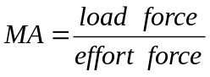
- In a first class lever, where does the fulcrum need to be placed to make it easier to lift a heavy object?

- Given the following data
  - calculate the theoretical MA of each lever
Effort arm (cm) | Load arm (cm) | Theoretical  Mechanical Advantage
20 cm | 80 cm
50 | 50
80 | 20
  - describe the relationship between the theoretical mechanical advantage and the length of the effort arm

  - If you compared the theoretical with the actual MA advantage, what would you find and why?

- A coyote sets up a class 1 lever so the fulcrum is 0.1 m from a large rock he is trying to lift and 5 m from the place where he will set and try to lift the rock from.
  - Calculate the theoretical mechanical advantage of this lever.

  - The 250 N coyote wishes to lift a 10000 N rock using the lever. Calculate the actual mechanical advantage required to lift this rock.

  - Will the coyote be able to lift the rock using only his weight with this lever? Explain

“Work”sheet
    - I can identify work input and work output in joules for a simple machine or mechanical system
- Work is when energy is transferred from one object to another using motion
- In order for work to be done, a force must be applied over a distance – if one is not present, then work is not done!
- Work is measured in joules or Newton-metres
- Work is calculated using the formula: Work = force x distance
- Make sure the force is measured in NEWTONS and the distance is measured in METRES – if it is not, then you will need to convert it to the proper units

- For each of the following, state whether work is being done on the object or not
  - A student pushes on a lever which opens a bottle
  - A coyote sits on a catapult to try to launch it but he doesn’t weigh enough to move it at all
  - You hold a book above your head
  - You walk up stairs
  - Pistons moving in a car engine turns the axle of a car, which turns the wheels and moves the car
  - You kick the wall but nothing happens to the wall.

- What effect does a machine have on the amount of work you do? (increase, decrease or stay the same?)

- Use your understanding of the work formula to explain why using a ramp to lift a box takes about the same amount of work as lifting it straight up, even though using the ramp makes it seem easier to do.

***SHOW ALL WORK!!! FORMULAS, SUBSITUTION, UNITS AND ANSWER***

- Calculate the work done in the following situations
  - A 15 N box is lifted 0.5 m.

  - You use a force of 40 N to push a box of books 3.2 m along the floor.

  - A 500 N table is pushed 200 cm up a ramp

  - A pulley is used to lift a 200 kg piano up 10 m. [Hint. Remember that a 1 kg object has a weight of 10 N]

  - Vivian and Christy were having a tug-of-war with their gym teacher. The distance to pull was 3 m. They pulled as hard as they could, but they could not move him! Assuming the teacher’s mass is 90 kg and Vivian and Christy pulled with force of 800 N, how much work did they do?

- Two students use a lever made of a log to push their parent’s car out of the ditch.
  - They push down on one end of the lever with 500 N of force. They move their end of the lever about 60 cm. Calculate the work input.

  - The car weighs 2500 N and has to be moved 10 cm upwards. Calculate the work output.

- A box of books has a weight of 1000 N and must be moved to a moving van 1 m above the ground. Sasha uses a ramp that is 5 m long and only has to push with 300 N of force. Calculate the work input and the work output.

- During the filming of a movie, a movable pulley is used to lift a 1200 N actor 5 m into the air. The backstage technician must pull on the rope with a force of 300 N. The length of the rope that the technician pulls on is 21 m. Calculate the work input and the work output.

Effects of Machines
A machine is a device that helps us to do work by doing one or more of the following
- Change direction of force (up to down or vice versa, linear to circular or vice versa)
- Makes it easier (less force)
- Makes it faster
- Transfer force (from one thing to another)
***Still requires same amount of work*** (actually it often requires more work because friction)
  - For example, if you reduce the amount of force required, you will have to spread that over a larger distance so it takes longer to complete the task (slower)
For each of the following machines, identify how it helps us do work and identify the effect that it has on force speed and work. The first one is done for you as an example.
Machine | How it helps us do work | Effect on force | Effect on speed | Effect on amount of work
- 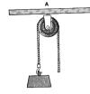 | Changes the direction | None | None | Increases slightly (because of friction)
- 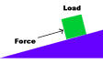

- 
- 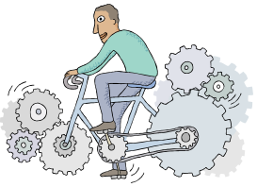

Energy
  - I can identify the source of energy for some familiar mechanical devices
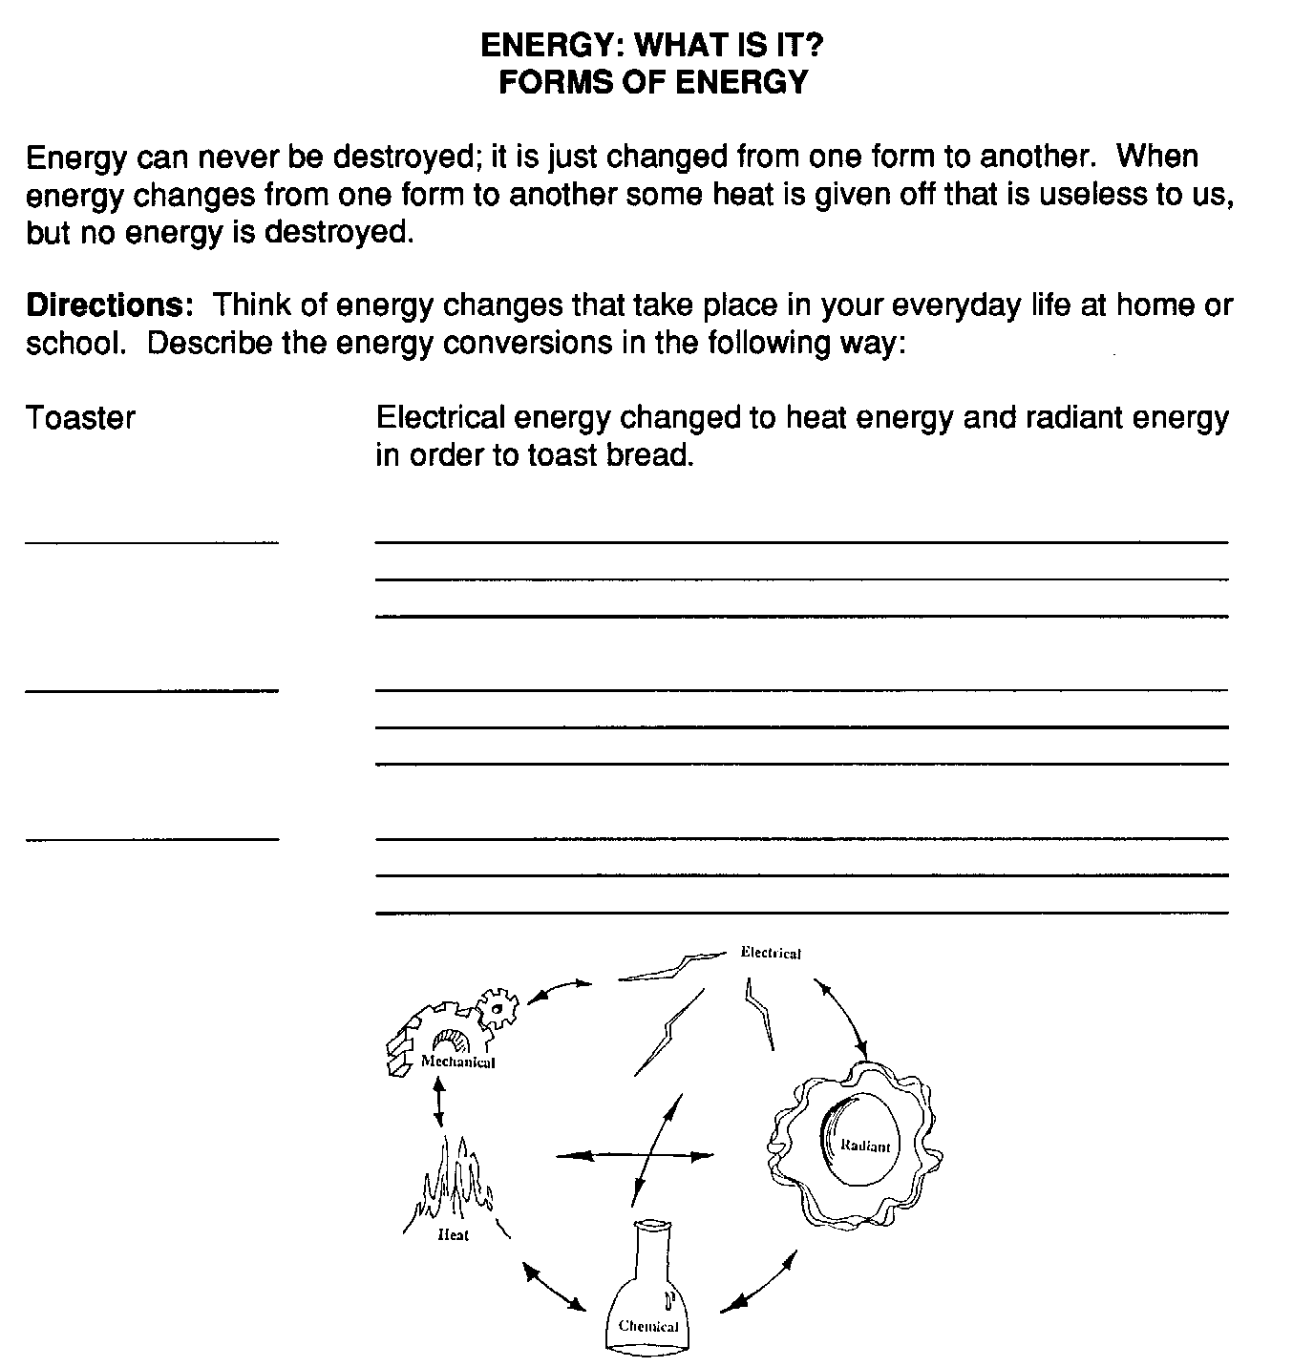

Procedure
  - Examine each photograph or device carefully. Operate if possible. Then describe the energy transformation. The first one is done as an example for you.

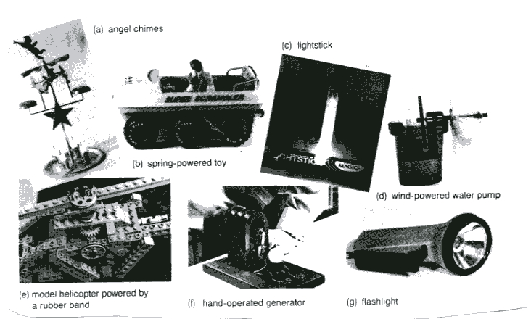

Efficiency
  - I can evaluate the design and function of a mechanical device in relation to its efficiency

- What is efficiency? (Don’t just write the definition, try to come up with at least three ways to describe it.)

- True or false. A car has an efficiency of 15%. This means that 15% of the energy put into the car is wasted and not used to move the car. Explain.

- What causes inefficiency in most machines? ____________________

- Why are complex machines usually less efficient than simple machines?

- How can you improve efficiency in mechanical systems?

- When is friction useful? (3 examples)

Efficiency can be calculated using the following formula:
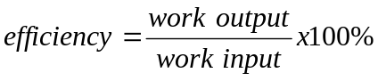
*** Remember that often you have to calculate work input and output first by multiplying force by distance

- A person puts in 1650 J of energy to push a box up the ramp. The work done by the ramp is 1430 joules (J). What is the efficiency of the ramp?

- Calculate the work input and the work output for the following simple machines. Then calculate the efficiency
  - Input Distance = 1.0m Output Distance = 0.5m
10.0 N
5.2 N

  - Distance arm is moved= 0.4 m Distance axe head moves = 0.8 m
4.0 N


10.0 N

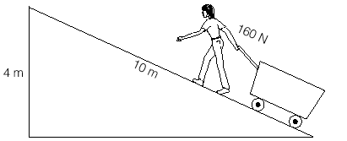

350 N
Gears and Sprockets
  - I can build or modify a model mechanical system to provide for different turning ratios between a driving and driven shaft
  - I can identify linkages and power transmissions in a mechanical device, and describe their general function
Gears are wheels with teeth (usually) that work together to transfer force and motion
- Can change force, speed and direction
- Two or more gears makes a gear train
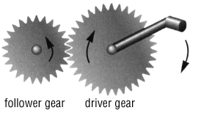 | Multiplying gears  - Speed advantage  - MA less than 1  - Gear ratio greater than 1
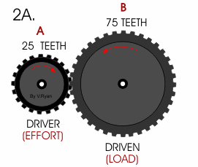 | Reducing Gears  - Force advantage  - MA greater than 1  - Gear ratio less than 1
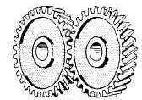 | Parallel Gears  - No advantage  - MA = 1  - Gear ratio = 1
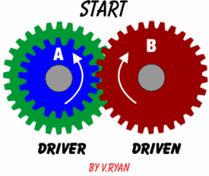 | - gears in direct contact with each other move in opposite directions.
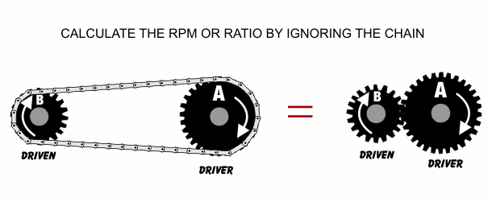 | - Sprocket gears are separated by linkages (chains)  - Gears in sprockets cause the gears to move in the same direction
- gear ratio - Measure of how the speed of an object is affected by the gears in a machine
Gear Ratio | Number of teeth on driver gear
Gear Ratio | Number of teeth on follower gear
*** you can also use the radius, diameter or circumference of the two gears to get your ratio
Gear Questions
- For each of the following
- identify whether it will change the direction of the follower gear or keep it the same
- identify whether it will give you a speed advantage or a force advantage
- calculate the gear ratio.

  - 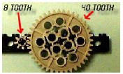
Driver Gear
  - 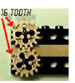
Driver Gear
  - 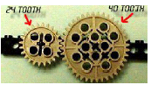
Driver Gear
  - 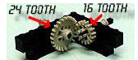
Driver Gear
  - 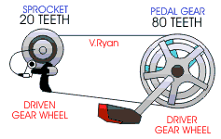
  - 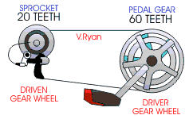
  - 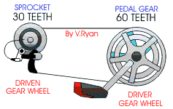
  - 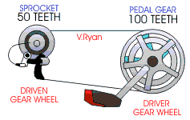
  - 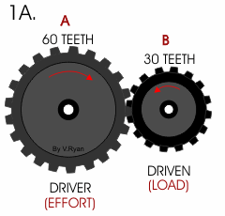
  - 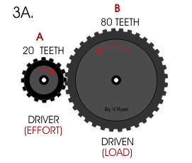
  - 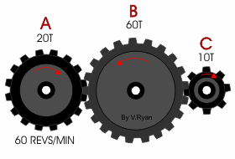
driver
driven

- If the driver gear is turning clockwise in each question, what direction will the driven gear turn?

Driver Gear
Driver Gear

- If you want to make the follower gear turn clockwise in the picture shown to the left, which way would you have to turn the driver gear?
Driver Gear
- Which gear train from ones below would you use if you wanted to
  - Travel quickly across a flat terrain?
  - pedal up a steep incline?

i
iii
ii

Pressure and Pneumatics

- What is the definition of pressure?

- What units (both forms) is pressure measured in?

- Write the pressure equation below.

- Use your understanding of pressure to explain how the protective equipment worn by football players prevents injuries.

- Your head exerts a force of about 50 N in the average car collision. If you hit the steering wheel with your forehead, approximately 3cm² of your head impacts the steering wheel.
  - Calculate the pressure of your head hitting the steering wheel.

  - If your head hits an airbag, approximately 300 cm² of your head is involved in the impact. Calculate the pressure of your head hitting the air bag.

  - Use your answers to a) and b) to explain why air bags are a common safety feature in many cars today.

- Joey builds a model hovercraft and makes a hole 1 cm² to force the air out of the machine. It works, but he wants to see if he can improve it so it goes faster. Hypothesize what he could do to improve the design and explain why it will work.

- What type of fluid do pneumatic devices use to exert pressure?

- What happens to the fluid in a pneumatic system?

- List as many examples of pneumatic systems as you can find in the text

- Briefly describe a pneumatic system found in the human body.

Hydraulics

- What type of fluid do hydraulic devices use to exert pressure?

- Is the fluid in hydraulic systems easily compressed? ________ Is the fluid in a hydraulic system sealed in? _________

- List as many examples of hydraulic systems as you can find in the text.

- Briefly describe a hydraulic system found in the human body.

- Draw a diagram of a hydraulic lift and label the input piston and the output piston.

- What is Pascal’s law?

- According to Pascal’s Law, if pushing down on a small piston produces 100N/m² of pressure, how much pressure will be produced at the large piston that is connected to it?

- If the pressure stays the same and the area of the piston gets larger, what happens to the force?

- Which piston needs to be larger in a hydraulic lift?

Pascal’s Law and Mechanical Advantage of Hydraulics
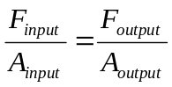
- The input piston of a hydraulic jack has an area of 25 cm² and the output piston has an area of 100 cm². How much force would you need to exert to lift a 500 N object?

- In a hydraulic lift, how large a piston would you need to lift a minivan? Assume that a person with a weight of 400 N is being used to lift a minivan with a weight of 12 000 N and the person is standing in a piston with an area of 0.5m². What must the area of the larger piston be?

- Suppose that you are able to exert a force of 300 N on the piston of a hydraulic lift. The piston has an area of 64 cm². What does the area of the other plunger have to be if you want to lift a load of 2000 N?

- A hydraulic lift has 2000N applied to an input piston that has an area of 50 cm². The output piston has an area of 200 cm². Calculate the maximum weight the hydraulic lift can move.

Use the formulas below to solve the following problems.

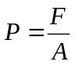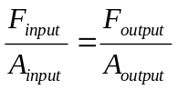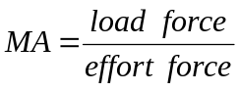

Work = F x d
- The input piston of a hydraulic jack has an area of 4 cm² and the output piston has an area of 100 cm².
  - How much force would you need to exert to lift a 500 N object?

  - What is the theoretical mechanical advantage of the hydraulic lift?

  - If the 500N object needed to be lifted 1 m, what would be the work output?

  - How far would the input piston have to be moved?

Technology over Time Assignment
Like many devices, the automobile has changed a great deal over the last 100 years. Developments in scientific understanding have brought about drastic changes in how cars are made and tested. Changing needs of society have put different emphases on aesthetics (looks), cost and safety at different times. Changes in the environment have forced automakers to look for alternative forms of fuel that are cleaner burning. This video looks at some of these changes.

As you watch the Nova car safety video and do internet research, complete the timeline assignment described below using the information to show how a technology such as automobile technology changes over time.

How to make your timeline
- turn your paper so the long side is at the top
- Fold your paper in half horizontally and trace a line where you folded
- On the bottom half of the page, you will record major changes in automobile design (make sure they go in order from the oldest to the newest as you move from left to right on the page)
- On the top half of the page you will identify reasons why the car design changed (make sure the “why” lines up with the right “how”). Some changes may have more than one reason! Also use symbols to identify each of the following things that might have impacted car design
  - Use a question mark to identify where trial and error (or accident) was used
  - Use an magnifying glass to identify where science has changed car design
  - Draw a stick person to identify where society has changed car design
  - Draw a tree to identify where the environment has changed car design



Major Changes in Automobile Design
Reasons for Change
Science
Environment
Society
Trial and Error

