Rube Goldberg Assignment

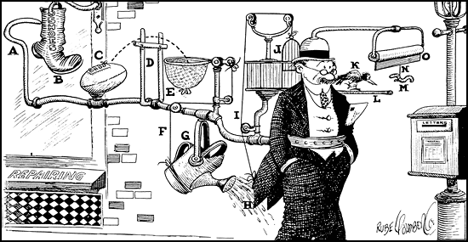

Background: Rube Goldberg was a cartoonist (New York Post) that became famous for drawing very complicated machines that performed very simple tasks. A typical Rube Goldberg device could not perform a job as straightforward as turning on a faucet without the assistance of pulleys, fulcrums, mousetraps, cables, and gears. By the time the cartoonist retired, the term “Rube Goldbergian” had been enshrined in the language to describe anything characterized by excess complexity. For more information, check out the Official Rube Goldberg site.

You will design a Rube-Goldberg Machine that uses multiple steps to complete a simple task. You may work with one partner and you may work construct both in and out of class. You may use almost any object you can find. You are limited to “safe” things. Stealing or borrowing other group’s materials result in a referral as well as major point reduction on your machine.

Assignment Requirements:
1. Machine Design:
You must use at least 4 different types of simple machines, but may use as many of each as needed. (For example, you may use 3 levers, 2 pulleys, and 1 inclined plane, etc.).
Each simple machine must be label on the back
• Must be neatly drawn and labeled using ABC’s to show order of steps from start to finish.
• Use good taste - no offensive drawings or words.
• Place your name and in the bottom right hand corner of the page.

2. Written Assignment:
You must also include a written report of your machine describing how it works and identifying the five simple machines you included. The parts of the written assignment are listed below:
• Grading will be based on originality, neatness, and meeting the requirements
outlined above. See me for any additional questions.

You must provide a sketch of your machine that shows the step-by-step operation of your machine.

Step 1-A ball rolls down the ramp
Step 2- The ball knocks down a block
Step 3-The block falls over
Step 4-It starts a car rolling

You must label each step A, B, C, etc. just like Rube Goldberg did.

Name:

Grading Rubric for Rube Goldberg Machine
Category | 1 | 2 | 3 | 4 | 5
Drawing | Sketch is partially drawn and is difficult to follow. Sketch and description do not match the machine. | Sketch is drawn, but difficult to follow or not labeled with letters. Sketch and description do not accurately represent machine | Sketch is drawn, easy to follow and labeled with letters.  Sketch and description are a fairly good representation of machine | Sketch is well drawn, easy to follow and labeled with letters.  Sketch and description accurately represent machine | Sketch is very well drawn, easy to follow and labeled with letters.  Sketch and description accurately represent machine
Written Section | Not completed,  or less than 4 simple machines labeled , with no explanation | Only 2-3 simple machines labeled or incorrectly labeled. Forgot to include explanation or only partially done | Four simple machines labeled mostly correct with a written explanation | Four simple machines labeled correctly with a well-written explanation for each | More than 4 simple machines labeled correctly with a well-written explanation for each
Creativity | Not completed | Poorly designed | Limited creativity. Relatively simple | Creative and well designed  Relatively complex | Very creative.  Very well designed.

Bonus marks:
Choose from the following options for up to a 20% bonus.
- Build the Rube Goldberg machine you designed.
- Calculate the Mechanical Advantage for the machine you designed.

Bonus points: /3
Total: /15

